Description:

Texture seam while moving sideways in front of the right corridor wall of the right appartment ( but probably could apply to all appartments

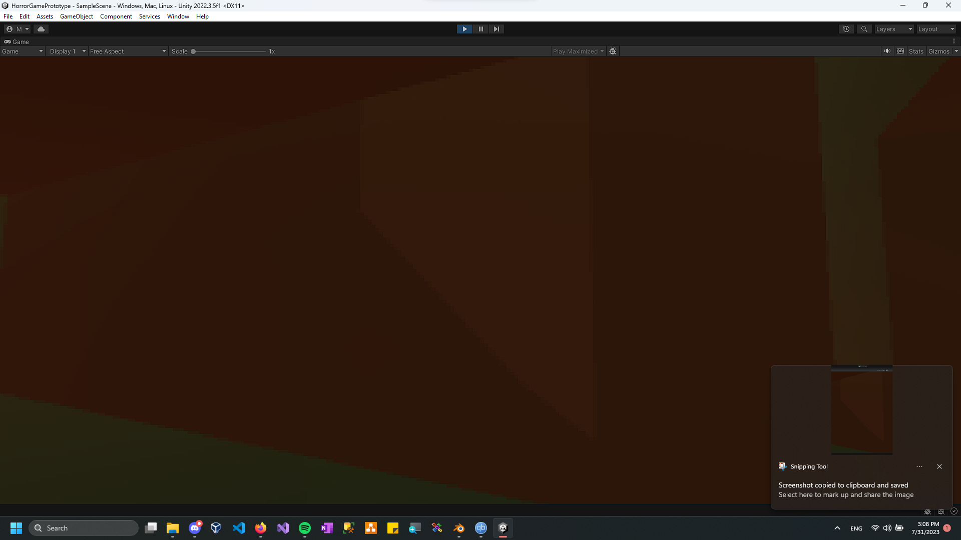

Solution:

It seems like there was an unnecessary Cube model in the blender scene, which initially would’ve been used for a staircase, but not anymore. The texture seam was caused by the Cube overlapping with the wall.